Attention All 2016-2017 Seniors
The following requirements must be met in order to have your picture in the yearbook. Please take this with you to your photographer. You or your photographer will need to email your senior picture to shsyearbook@sapulpaps.org All pictures will need to be in tiff or jpeg file format, a 2x3 at 600 DPI or more resolution. Senior picture deadline is December 10th. NO EXCEPTIONS. Otherwise your school picture day picture will be submitted. We prefer you email your digital image. If your need to drop off a print, you may drop it off in room 614 before school or after school or at lunch. Photos may be in either black and white, color, indoor, or outdoor.
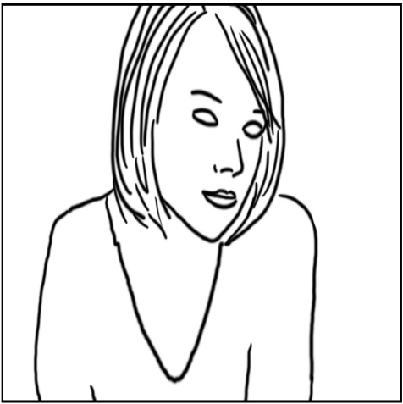
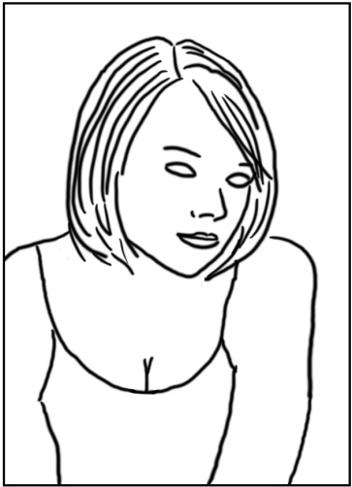
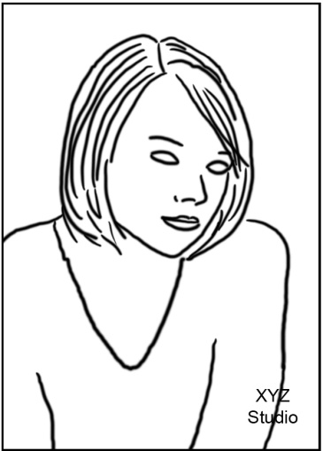

No horizontal No Logo not school appropriate
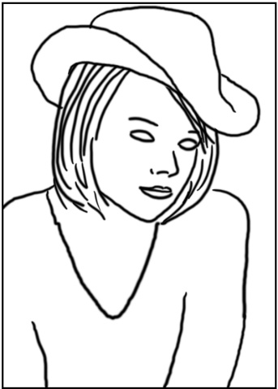
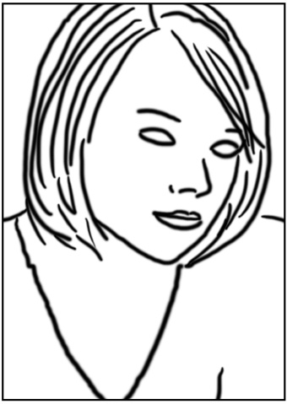
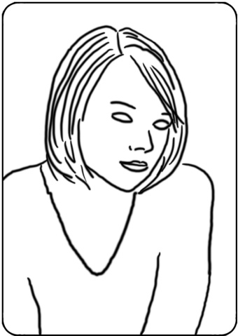
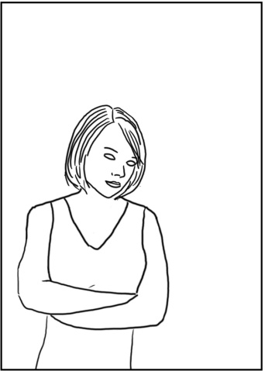

Too far no rounded edges too close no hats

